
Symbiosis Institute of Technology, Pune
Faculty of Engineering
CSE- Academic Year 2026-27
Java Programming – Lab Batch 2024-28
Lab Assignment No:- 12
Name of Student | Aarushi Raizada
PRN No. | 25070122002
Batch | 2025-29
Class | A1
Academic Year & Semester | 2026 Sem III
Date of Submission | 20th August’26
Title of Assignment: | Write a Java program to create and use user-defined packages.
Theory  Practice questions | Packages are used to organize related classes and interfaces into namespaces. User-defined packages improve code organization, reduce naming conflicts, and enhance reusability. They also support access protection and modular application development. Java packages simplify project management by grouping logically related components together. Largescale software systems extensively use packages.  1. Create a Java program by developing user-defined packages for a College Management System. Create separate packages for student and faculty details, and display their information using classes from these packages.  package College.Student;  public class student1 {  public void display() {  System.out.println("Student Name: Aarushi");  System.out.println("Roll No: 101");  }  }  package College.Faculty;  public class faculty {  public void display() {  System.out.println("Faculty Name: Rahul");  System.out.println("Department: CSE");  }  }  import College.Student.student1;  import College.Faculty.faculty;  public class main1 {  public static void main(String[] args) {  student1 s = new student1();  faculty f = new faculty();  s.display();  f.display();  }  }  2. Create a Java program by developing a user-defined package named library that contains a class to store and display book details such as book ID, title, author, and price. Import the package into the main program and display the book information.  package library;  public class book {  public void display() {  System.out.println("Book ID: 101");  System.out.println("Title: Java Programming");  System.out.println("Author: James Gosling");  System.out.println("Price: 500");  }  }  import library.book;  public class main2 {  public static void main(String[] args) {  book b = new book();  b.display();  }  }
Output Screenshots (if applicable) | Ans 1  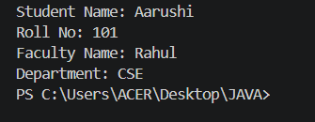  Ans 2  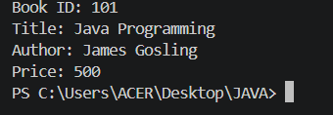
Conclusion | In this experiment we learnt to create and use user-defined packages for organizing Java programs.

